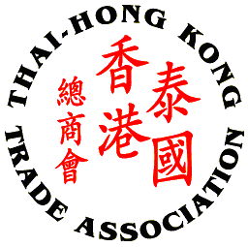
Thai - Hong Kong Trade Association

THTA CHINESE NEW YEAR CELEBRATION 2015

SPONSORSHIP REPLY FORM

Please complete this form and return to THTA Office via E-mail: thai-hongkong@thta.or.th or Fax: 02 343 9029 by Monday, 2nd March 2015

Company/Sponsor Name: ___________________________________________________
Company Address: _________________________________________________________
_________________________________________________________________________
Contact Person’s Name: ___________________________ Position: ________________
Tel No.: ________________ Fax No.: ________________ Email: __________________

Sponsorship Packages: (Please tick √ one of the following)

Platinum Sponsor: 20,000 Baht Inc. VAT 7%
- 15 Minutes of Company/ Product and Service Presentation
- Booth and/or sponsor’s promotional activities
- One roller-up banner to be provided by sponsor
- Company name/logo prominently displayed on the e-invitation and Backdrop, larger than other companies and organisations
- Company name/logo on all correspondence and Thank you email
- Recognition of contribution on website, with logo display

Gold Sponsor: 10,000 Baht Inc. VAT 7%
- Booth and/or sponsor’s promotional activities
- One roller-up banner to be provided by sponsor
- Company name/logo prominently displayed on the e-invitation and Backdrop
- Company name/logo on all correspondence and Thank you email
- Recognition of contribution on website, with logo display

Silver Sponsor: 5,000 Baht Inc. VAT 7%
- One roller-up banner to be provided by sponsor
- Company name/logo prominently displayed on the e-invitation and Backdrop
- Company name/logo on all correspondence and Thank you email
- Recognition of contribution on website, with logo display
***For your kind sponsorship, please attached your company logo file to displayed on the event***

Cheque payment to be made to: Thai - Hong Kong Trade Association
Payment Option: Direct transfer to Krung Thai Bank, Queen Sirikit National Convention Center Branch, Saving Account, A/C No. 009-1-726-336

Remark: Please fax payment slip when you have paid via direct bank transfer to THTA via E-mail: thai-hongkong@thta.or.th or Fax: 02 343 9029

Signature: ____________________

( )
Date: ________________________

